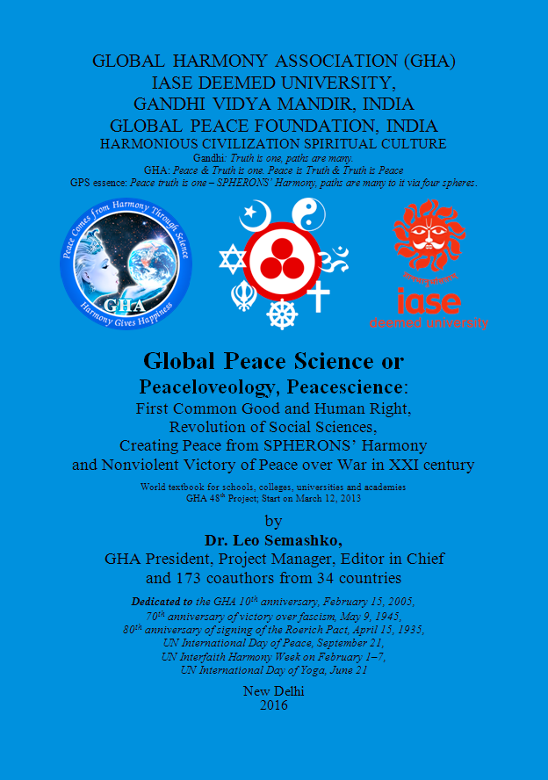

<http://peacefromharmony.org/docs/global-peace-science-2016.pdf>

Global Peace Science (GPS):

The Book, its Authors and Significance. Resume

In Russian: <http://peacefromharmony.org/?cat=ru_c&key=662>

In English: <http://peacefromharmony.org/?cat=en_c&key=656>

In French: <http://peacefromharmony.org/?cat=fr_c&key=137>

In Portuguese: <http://peacefromharmony.org/?cat=po_c&key=87>

In Spanish: <http://peacefromharmony.org/?cat=es_c&key=109>

In Greek: <http://peacefromharmony.org/?cat=gr_c&key=9>

In Arabic : <http://peacefromharmony.org/?cat=ar_c&key=8>

In Esperanto: <http://peacefromharmony.org/?cat=esp_c&key=88>

In Persian: <http://peacefromharmony.org/?cat=ar_c&key=9>

*The positive fate of humanity and each country in the 21st century will be*

*determined by the recognition of GPS and its democracy of SPHERONS*.

GHA

*First they ignore you, then they laugh at you,*

*then they fight you, then you win.*

Gandhi

The unprecedented ***Global Peace Science*** (GPS or Peacescience), published at the book some name, was created in the Global Harmony Association (GHA) for 11 years since its establishment on February 15, 2005. Of these, 8 were the preparatory years, for which GHA has published seven previous books, discussed and approved 47 projects of global peace from harmony (Chapter 7.1). Work with GPS as the 48th project began directly in March 2013.

In Russian language, this book of 432 pages by 89 coauthors from 30 countries was published in St. Petersburg, Russia, in January 2015:

<http://peacefromharmony.org/docs/Nauka-globalnogo-mira-2015.pdf>.

In English language, this book of 616 pages (almost 200 pages longer Russian one) by 174 coauthors (on 85 more than the Russian edition) of 34 countries was published in the early February 2016 in India, Russia and the USA: <http://www.lulu.com/shop/dr-leo-semashko-and-173-co-authors/global-peace-science-updated/paperback/product-22605037.html>. Its PDF format was posted in January here: <http://peacefromharmony.org/docs/global-peace-science-2016.pdf>.

The book coauthors are people of different age (from 9 to 90) and professions (from worker to academician and president of the country), 15 religious confessions and diversity of cultures from 34 countries in all continents, including 59 coauthors from the USA, 33 – from Russia, 15 – from India, 6 – from Canada, 5 – from Australia, etc. Only international group integrating in a harmonious unity the planet cultural diversity could create Peacescience.

Among the Peacescience coauthors are: former President of India – Abdul Kalam, the Nobel Peace Laureate from Northern Ireland – Mairead Maguire, intellectual peacemaking leader of the USA – Noam Chomsky, pioneer of peace studies from Norway – Johan Galtung, Chancellor of the IASE Pedagogical University of India – Kanakmal Dugar, sociologist of Catholic University from Belgium – Francois Houtart, leader of the women's peace-making organization in Africa – Ayo Ayoola-Amale of Ghana, researcher of the Roerich creativity – Julia Budnikova from Russia, director of the Finance Institute, academician from Kazakhstan – Uraz Baimuratov, one of the Indian yoga leaders – Ramesh Kumar and many other outstanding scientists and peacemakers (6). Initiator, editor in chief and manager of the project is Leo Semashko, GHA Founder and President, Russia.

The contribution of these authors in GPS for three years composed 309 articles, including Leo Semashko 101 articles (81 solo and 20 coauthorship), Subhash Chandra 17 articles (10 solo and 7 coauthorship), Charles Mercieca 6 articles (5 solo and 1 coauthorship), Johan Galtung 5 articles, etc.

The book 309 articles are united into its 13 Chapters, 3 Sections, 2 Parts, Annex and Philosophical Final, which have been a collective discussion and approval of the GHA members. The most important parts of this three years discussion in a wide variety of assessments and comments of Peacescience were posted here: <http://peacefromharmony.org/?cat=en_c&key=598>. Diversity of opinions is complemented a variety of more than 600 sources in the book bibliography on 17 pages (580–597).

The GPS book is published on the GHA 72 members donations gathered in 2014 and amounting $8.677. It is the first budget of global peace in the history in 2015. Its comparison with the world military budget this year, nearly $ 2 trillion (according to unofficial data it is several times more), shows the militaristic, self-destructive priority of the global ruling elite and its national governments. Unfortunately, humanity has long reconciled with this priority and it is not looking to change it that is possible only on the GPS basis.

We will not talk about the shortcomings that Peacescience are full as the first attempt of similar science. We will emphasize its key advantages and significance.

1. Uniqueness. Peacescience is incomparable to anything else today. Mankind today does not have any similar or comparable knowledge of global peace, alternative to military science that has arisen over two centuries ago in 1799. GPS is able to overcome this lag of peace from war and create a fundamental alternative to military science and militarism in general. Uniqueness of GPS is determined by the discovery of SPHERONS – deep harmonious social structure of society in all its historical forms. This unknown up to GPS creation deep structure is peaceful on its objective nature and the key for scientific understanding global peace.

2. SPHERONS’ discovery. GPS is based on the unprecedented social discovery of universal and harmonious classes of the population in a whole – SPHERONS employed in four spheres of social production, which is possible only in peace. Therefore SPHERONS are fundamental actors not only production but also global peace at all social levels, starting from the family. SPHERONS constitute a deep and eternal social structure of society as a whole and all its parts, without exception, in all its historical forms (Chapters 1 and 2). The discovery of SPHERONS has a revolutionary cognitive, social and political (democratic) significance for society.

This discovery is complemented by the discovery of Socioeconomic Harmony Paradigm: "D + 3D", which expresses the spiritual/ethical basis ("D" – of Russian “Duh” - spirit) of harmonious development and adequate to it the development of other three "D" spheres: demography (Sociosphere), democracy (Orgsphere) and demo-economy (Technoecosphere). The essence of a Harmony Basic Law in this paradigm is priority elevation of the spiritual needs for the individuals and society, which is opposed to disharmonious Law of destructive domination of material needs. (It is Academician Baymuratov’s Paradigm, 2014, Kazakhstan. See Chapter 8.15).

3. Integral, holistic character and dynamism. Peacescience, thanks SPHERONS universality, allows to synthesize and preserve in itself the peacemaking achievements of the past and future evolution (Chapters 3, 4, etc.). It provides a holistic approach to solving the problems of global peace at all levels. GPS does not pretend to finality but it assesses itself as "the initial version", which does not exclude other options and is ready to enter with them into international scientific Contest (Chapter 8, etc.). It supposes the possibility of another interpretation for deep social structure.

4. Value of Peacescience. In any case, regardless of the Peacescience truth measure of its various theories, it is an undoubted epistemological achievement and social value as the first in history precedent of scientific knowledge of global peace in a whole (history does not know other similar examples). Therefore, following the wise Italian saying "*If it is not true, it is well conceived," (se non è vero, è ben trovato*) about Peacescience can say that even if it is not right in all parts, it is well conceived and certainly useful to mankind. Peacescience opens for it the way of search and upgrading an absolutely necessary for it science and fundamentally new, breakthrough knowledge, enriching it and saving it from wars, from which it is still (for the 6 thousand years of history) not has the radical vaccine and spiritual immunity. It is the way of conscious geopolitics of SPHERONS’ peace under the Earth Constitution International Law. Peacescience opens the Peacefulness Era of humanity since 2016.

The completion of the Peacescience book in GHA is just the beginning of a new, broader development, dissemination and application of the GPS new paradigm of thinking in academic, educational, political, religious and other cultural institutions.

Resume. Peacescience from harmony defines the THIRD, harmonious and just way of humanity development in all its four spheres. The third way organically integrates the advantages and softly (non-violently) overcomes the pathological extremes of the two equally disharmonious and violent, traditional for the 20th century ways: socialism and capitalism and their basic ideologies: Marxism and liberalism. The past and the beginning of the new century showed that without scientifically conscious and realized social harmony live further in a nightmare of any militaristic form of traditional society, mired in endless wars, terrorism, murders, crimes, corruption, lies, elitist-totalitarian pseudo democracy of billionaires behind the screen of the elected puppets, drugs, glaring inequality, and other pathologies on the brink of the world's nuclear suicide is impossible. GPS offers a way out of their impasse through science, education, culture and democracy of SPHERONS as the political center of the federalist Earth Constitution (Chapter 8.19). Therein lies the GPS historical significance.

Top. The fate of humanity and its key countries in the 21st century with different cultural, economic and political orientations: Russia, China, India, EU and the US, will be determined by the recognition of GPS and its democracy of SPHERONS (spheral democracy) ensuring the dominance of spiritual elevation, social priority of children and women, geopolitics of global peace, general and complete disarmament and economic prosperity for all nations from their harmony as one family on one planet.

Dr. Leo Semashko, GHA President, GPS Editor in Chief

Leo Semashko, Ph.D. (Philosophy), Founding President, Global Harmony Association (GHA) since 2005; State Councilor of St. Petersburg; Philosopher, Sociologist and Peacemaker from Harmony; Author of more than 400 scientific publications, including 18 books in 1-12 languages; Author of *Tetrism* as the unity of *Tetraphilosophy* and *Tetrasociology* – science of social harmony, global peace and harmonious civilization; Director: Tetrasociology Public Institute, Russia; Director, GHA Website “*Peace from Harmony*”: <http://peacefromharmony.org>; Initiator, Manager and Editor in Chief of the book project “*Global Peace Science*” (GPS).

Address: St-Petersburg, Russia; Phone: +7(812)-597-6571

E-mail: [leo.semashko [at] gmail.com](mailto:leo.semashko@gmail.com)